African Continental Free Trade Area: What you need to know
African leaders are set to launch AfCFTA, the biggest free trade agreement since the establishment of the WTO.
by Loes Witschge

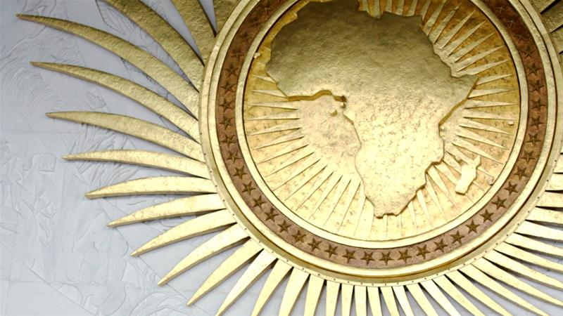The African Union headquarters is based in Addis Ababa, Ethiopia [File: Jonathan Ernst/Reuters]
African countries are set to put their signature to an agreement that will launch the African Continental Free Trade Area (AfCFTA) in Kigali, Rwanda, on Wednesday.
The UN Economic Commission for Africa (UNECA) has estimated the agreement's implementation could increase intra-African trade by 52 percent by 2022, compared with trade levels in 2010.
Here's what you need to know about the biggest trade agreement signed since the World Trade Organization (WTO) was established.

What is AfCFTA?
African heads of government agreed to establish a continental free trade area in 2012 and started negotiations in 2015.
The agreement is set to be signed by all 55 member states of the African Union, bringing together 1.2 billion people with a combined gross domestic product (GDP) of more than $2 trillion.
The draft agreement commits countries to removing tariffs on 90 percent of goods, with 10 percent of "sensitive items" to be phased in later.
The agreement will also liberalize services and aims to tackle so-called "non-tariff barriers" which hamper trade between African countries, such as long delays at the border.
Eventually, free movement of people and even a single currency could become part of the free trade area.

Why a single market for Africa?
By creating a single continental market for goods and services, the member states of the African Union hope to boost trade between African countries.
Intra-African trade is relatively limited; UNCTAD, the main UN body dealing with trade, said it made up only 10.2 percent of the continent's total trade in 2010.
David Luke, coordinator of the African Trade Policy Centre at UNECA, hopes the free trade area will correct this "historical anomaly".
"Colonialism created a situation where neighbors stopped trading with each other. The main trading route was between African countries and European countries and between African countries and the US," he told Al Jazeera.
Removing barriers to trade is expected to not just grow trade within Africa, Luke said, but also grow "the kind of trade this continent needs".
Between 2010 and 2015, fuels represented more than half of Africa's exports to non-African countries, while manufactured goods made up only 18 percent of exports to the rest of the world, a UNECA report said.
When you have this kind of economy, your young people cannot find jobs. And when they cannot find jobs, you see them trying to get to Europe and drowning in the Mediterranean.
DAVID LUKE, AFRICAN TRADE POLICY CENTRE, UNECA
Within Africa, 43 percent of goods traded are manufactured products.
Commodity prices are volatile, making economies that rely on their export vulnerable. Moreover, Luke said, the export of commodities tends to be capital- rather than labor-intensive.
"When you have this kind of economy, your young people cannot find jobs. And when they cannot find jobs, you see them trying to get to Europe and drowning in the Mediterranean," Luke said.
"If you are making the basic things that everybody consumes, then you are creating jobs."
Luke hopes the free trade area will also make Africa more competitive outwardly.
"If you can move further up the supply chain, you are better placed in a global context as well," he said.

What are the challenges?
On Sunday, Nigerian President Muhammadu Buhari cancelled his attendance at the signing ceremony. A statement said the decision was made "to allow time for broader consultations".
The Nigeria Labor Congress (NLC) had warned Buhari against signing the agreement, calling it a "renewed, extremely dangerous and radioactive neo-liberal policy initiative".
Nigeria's sudden stalling signals that not everybody is satisfied individual countries will be better off under the deal.
A research paper by UNCTAD concedes that elimination of all tariffs between African countries would take an annual $4.1bn out of the trading states' coffers, but would create an overall annual welfare gain of $16.1bn in the long run.
But there are fears that the benefits of the free trade area could be unevenly distributed.
Sylvester Bagooroo, a program officer at Third World Network Africa, thinks the treaty focusses too much on cutting tariffs, without sufficient consideration of the varying production capabilities of African countries.
Africa's most advanced countries are at an advantage with their more strongly developed manufacturing capabilities. Allowing them to sell their goods and services to the continent's less developed countries could undercut industrial development there.
"If you don't build on productive capacities, when you liberalize you are only going to be trading imported goods across Africa, and that will be a big blow to domestic manufacturing across the continent," Bagooroo said.
"We need to pay attention to the big economies against the small economies. We need to pay attention to the dominant sectors against the weaker sectors."
Eyerusalem Siba, a research fellow at the Brookings Institution's Africa Growth Initiative, is concerned with the domestic policies "which need to be in place to assist workers and also businesses when competition increases".
It’s a good idea to integrate eventually, but are we ready for it? Not every expert I have spoken with agrees with it.
EYERUSALEM SIBA, BROOKINGS INSTITUTION
Governments will need to develop a more skilled workforce adaptable to the demands of globalization and at the same time create social policies for those who will lose jobs due to increased competition, Siba said.
"Competition tends to have a detrimental impact on wages in low-cost jobs, so countries need to think about how they're going to address that situation.
"At the same time countries which are already connected to the global economy may benefit from integration, while others have to wait for the benefits to trickle down."
"It’s a good idea to integrate eventually, but are we ready for it? Not every expert I have spoken with agrees with it," she concludes.

What's next?
The text to be signed on March 21 contains the legal framework for the free trade area, which will then need to be ratified by the individual countries through their respective domestic processes.
AfCFTA will come into force after it has been ratified by either 15 or 22 countries - a number that has yet to be agreed on.
A second phase of negotiations will be held later to cover investment, competition policy and intellectual property.
There are other details that still need to be ironed out; countries will need to submit which products they consider "sensitive", thus exempting them from the tariff cut for now, for example. And the African Union Commission will need to establish a secretariat to preside over the agreement.
Still, UNECA's Luke is hopeful African countries will move "very quickly".
"This is something that the Africans have said they want to do for themselves. It's not the World Bank; it's not the IMF, it's not anybody saying 'You better do this or we'll withhold something from you'. This is something that they voluntarily wanted to do.
"We do expect that they would want to get this treaty up and running as quickly as possible," Luke said.

